

**Department of Electrical and Computer Engineering**

| Course Number | CPS510 |
| --- | --- |
| Course Title | Database Systems I |
| Semester/Year | F2022 |
| Instructor | Dr. S. B. Tajali |
| Lab Section | 7 |

| Assignment No. | 7 |
| --- | --- |
| Assignment Title | Assignment 7: Normalization/3NF |

| Submission Date: | November 07, 2022 |
| --- | --- |
| Due Date: | November 07, 2022 |

| Student Name | Ethan Moo-Young | Ernestine Ho | Abel Abraham Thomas |
| --- | --- | --- | --- |
| Student ID | 501016708 | 501022253 | 501029194 |
| Signature |  |  |  |

Tables created before A07

Contents of [Book] Table

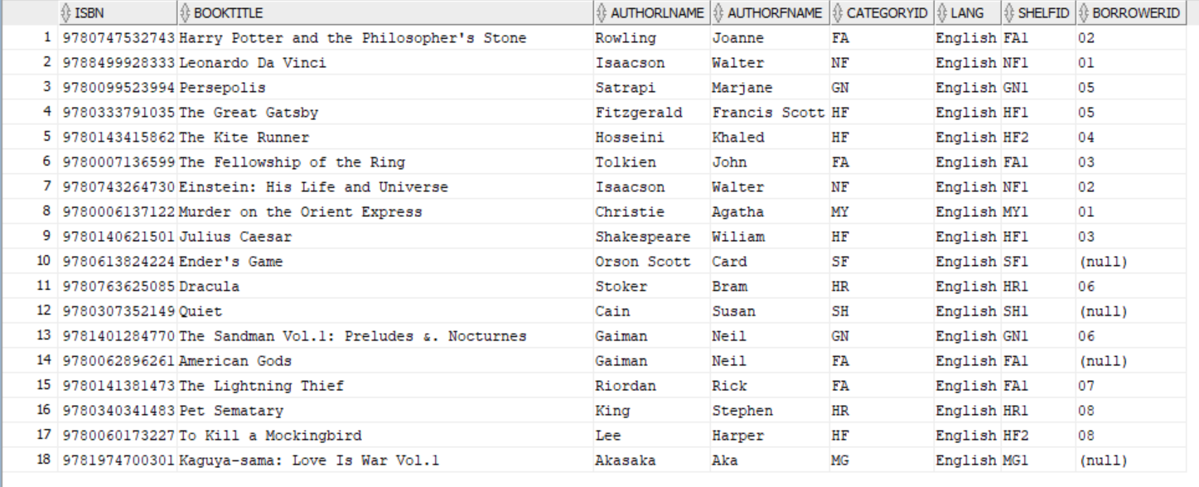

Contents of [Category] Table

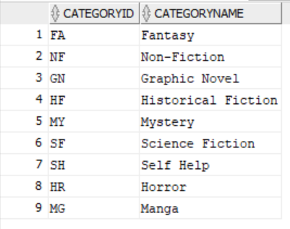

Contents of [Client] Table

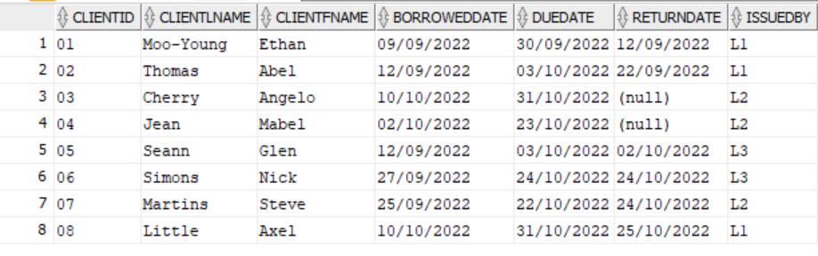

Contents of [Shelf] Table

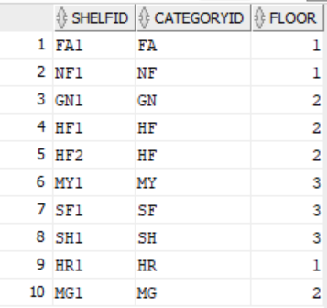

Contents of [Staff] Table

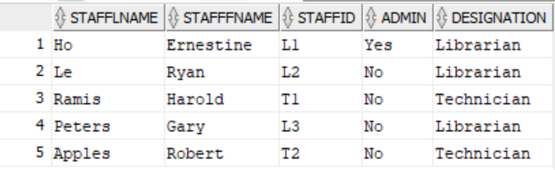

Updated Normalized Tables

Contents of [Book] Table

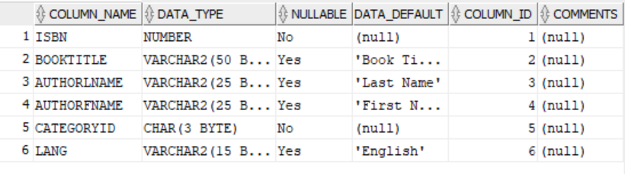

FDs(ISBN -> BookTitle, AuthorLname, AuthorFname, CategoryId, Lang)

Contents of [BorrowedBooks] Table

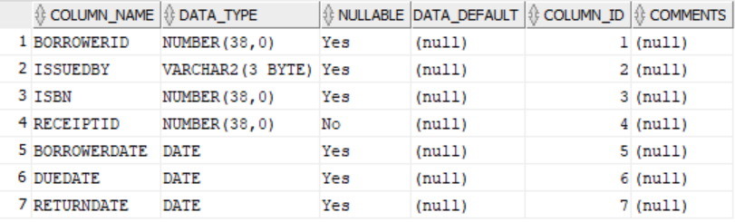

FDs(ReceiptID -> IssuedBy, ISBN, BorrowerID, BorrowerDate, DueDate, ReturnDate)

Contents of [Category] Table

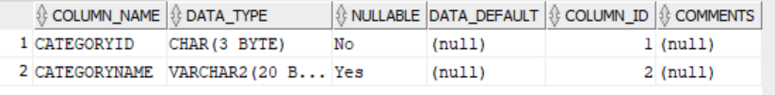

FDs(CategoryId -> CategoryName)

Contents of [Client] Table

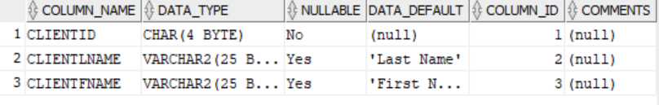

FDs(ClientId -> ClientLname, ClientFname)

Contents of [Shelf] Table

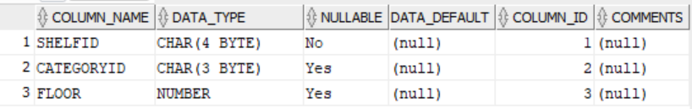

FDs(ShelfId -> CategoryId, Floor)

Contents of [Staff] Table

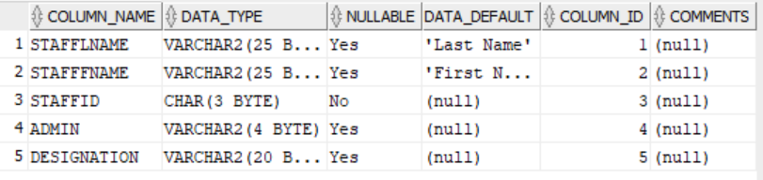

FDs(StaffId -> StaffLname, StaffFname, Admin, Designation)